TITLE OF THE JOURNAL SHOULD BE WRITTEN HERE(Align Left, Bold, 16pt)

First name M. I. Surname¹, First name A. I. Surname ², First name M. I. Surname³ (10 pt)

^{1, 3} Department of Networks Engineering, Al-Nahrain University. Iraq (9 pt)

² Department of Electrical Engineering, Newcastle University, UK
¹ Email: xxxxx@xxx.com; ORCID: https://orcid.org/xxxx-xxxx-xxxx-xxxx
² Email: xxxxx@xxx.com; ORCID: https://orcid.org/xxxx-xxxx-xxxx-xxxx
³ Email: xxxxx@xxx.com; ORCID: https://orcid.org/xxxx-xxxx-xxxx-xxxx
(Received: 0/0/00; Accepted: 00/00/000)
1.5-spaced, One Column

Abstract- The word Abstract is in bold italics, but the content of the abstract is in bold (without italics). The abstract should include a concise overview of the study's overall objectives, primary findings, methodology, significance, and conclusions. The abstract should be between 150-200 words. It is not Allowed to use abbreviations in the abstract. (9 pt).

Keywords: First keyword, Second keyword, Third keyword, Fourth keyword, Fifth keyword
I. Introduction (Bold, 12 pt)
This is IEEE Text style. Use it for all paragraphs that contain body text. This style matches the appearance of papers in an IEEE conference proceedings but in double-spaced (actually it is 1.5 spaced) format and in a single column. For items not addressed in these instructions, please refer to other documents on IEEE style.
A. This is IEEE Subheading Style
Prepare your paper in full-size format (i.e., use this document as your template), on US letter paper (8.5 by 11 inches).
Type sizes and typefaces: Follow the type sizes specified in Table I. As an aid in gauging type size, 1 point is about 0.35 mm. The size of the lowercase letter “j” will give the point size. Times New Roman is the preferred font.
1) US letter margins (inches): top = 1 inch, bottom = 1 inch, side = 1 inch.
2) US letter margins (mm): top = 25.4 mm, bottom = 25.4 mm, side = 25.4 mm.
Paragraph indentation is 3.5 mm (0.14 in).
Left- and right-justify your columns. Use automatic hyphenation and check spelling. Digitize and electronically paste all figures into the document.

TABLE I
Type Sizes for Camera-Ready Papers
Paragraph Style | Size  (pts) | Font | Font Style | Description
IEEE Title | 16 | Times New Roman | regular | Title of paper
IEEE Author | 10 |  | regular | Author names
IEEE Abstract | 10 |  | italics | Abstract of paper
IEEE Heading 1 | 10 |  | capital Caps, Bold | Section headings
IEEE Heading 2 | 10 |  | Italics, Capitalize Words | Sub-headings
IEEE Text | 10 |  | regular | All body text
IEEE List | 10 |  | Italics # and topic: regular text | Lists
IEEE Table Number | 8 |  | ALL CAPS | Table Number
IEEE Table Title | 8 |  | Small Caps | Table Title
IEEE Table Content | 8 |  | regular | Table content
IEEE Caption | 8 |  | regular | Figure caption
IEEE Equation | 10 |  | regular | Equation
IEEE Reference Head | 8 |  | Small Caps | Reference section heading
IEEE Reference | 8 |  | regular | Reference entry
II. Helpful Hints
B. Figures and Tables
Position figures and tables at the tops and bottoms of pages, when possible. Avoid placing them in the middle of columns. Figure captions should be centered below the figures; table captions should be centered above. Avoid placing figures and tables before their first mention in the text. Use the abbreviation “Fig. 1,” even at the beginning of a sentence.
Figure axis labels are often a source of confusion. Use words rather than symbols. For example, write “Magnetization,” or “Magnetization, M,” not just “M.” Put units in parentheses. Do not label axes only with units. In the example, write “Magnetization (A/m)” or “Magnetization (A ⋅ m¹).” Do not label axes with a ratio of quantities and units. For example, write “Temperature (K),” not “Temperature/K.”
Multipliers can be especially confusing. Write “Magnetization (kA/m)” or “Magnetization (10³ A/m).” Figure labels should be legible, about 10-point type.
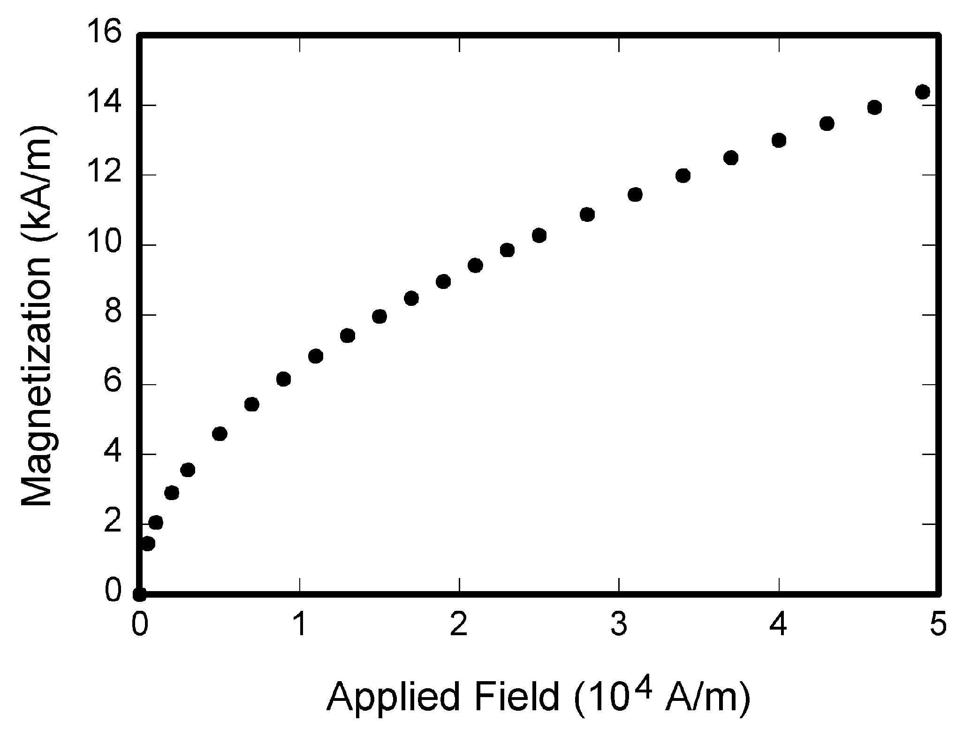
Figure 1. Magnetization as a function of applied field.
Note how the caption is centered in the column.

C. References
Number citations consecutively in square brackets [1]. Punctuation follows the bracket [2]. Refer simply to the reference number, as in [3]. Use “Ref. [3]” or Reference [3]” at the beginning of a sentence: “Reference [3] was the first …”
Number footnotes separately in superscripts. Place the actual footnote at the bottom of the column in which it was cited. Do not put footnotes in the reference list. Use letters for table footnotes (see Table I). IEEE Transactions no longer use a journal prefix before the volume number. For example, use “IEEE Trans. Magn., vol. 25,” not “vol. MAG-25.
Give all authors’ names; use “et al.” if there are six authors or more. Papers that have not been published, even if they have been submitted for publication, should be cited as “unpublished” [4]. Papers that have been accepted for publication should be cited as “in press” [5]. In a paper title, capitalize the first word and all other words except for conjunctions, prepositions less than seven letters, and prepositional phrases.
For papers published in translated journals, first give the English citation, then the original foreign-language citation [6].
D. Abbreviations and Acronyms
Define abbreviations and acronyms the first time they are used in the text, even if they have been defined in the abstract. Abbreviations such as IEEE, SI, MKS, CGS, sc, dc, and rms do not have to be defined. Do not use abbreviations in the title unless they are unavoidable.
E. Equations
Number equations consecutively with equation numbers in parentheses flush with the right margin, as in (1). To make your equations more compact, you may use the solidus ( / ), the exp function, or appropriate exponents. Italicize Roman symbols for quantities and variables, but not Greek symbols. Use an en dash (–) rather than a hyphen for a minus sign. Use parentheses to avoid ambiguities in denominators. Punctuate equations with commas or periods when they are part of a sentence, as in
a + b = c. (1)
Symbols in your equation should be defined before the equation appears or immediately following. Use “(1),” not “Eq. (1)” or “equation (1),” except at the beginning of a sentence: “Equation (1) is …”
F. Other Recommendations
The Roman numerals used to number the section headings are optional. If you do use them, do not number Acknowledgment and References, and begin Subheadings with letters. Use two spaces after periods (full stops). Hyphenate complex modifiers: “zero-field-cooled magnetization.” Avoid dangling participles, such as, “Using (1), the potential was calculated.” Write instead, “The potential was calculated using (1),” or “Using (1), we calculated the potential.”
Use a zero before decimal points: “0.25,” not “.25.” Use “cm³,” not “cc.” Do not mix complete spellings and abbreviations of units: “Wb/m²” or “webers per square meter,” not “webers/m².” Spell units when they appear in text: “…a few henries,” not “…a few H.” If your native language is not English, try to get a native English-speaking colleague to proofread your paper. Do not add page numbers.
III. Units
Use either SI (MKS) or CGS as primary units. (SI units are encouraged.) English units may be used as secondary units (in parentheses). An exception would be the use of English units as identifiers in trade, such as “3.5-inch disk drive.”
Avoid combining SI and CGS units, such as current in amperes and magnetic field in oersteds. This often leads to confusion because equations do not balance dimensionally. If you must use mixed units, clearly state the units for each quantity that you use in an equation.
IV. Some Common Mistakes
The word “data” is plural, not singular. The subscript for the permeability of vacuum₀ is zero, not a lowercase letter “o.” In American English, periods and commas are within quotation marks, like “this period.” A parenthetical statement at the end of a sentence is punctuated outside of the closing parenthesis (like this). (A parenthetical sentence is punctuated within the parentheses.) A graph within a graph is an “inset,” not an “insert.” The word alternatively is preferred to the word “alternately” (unless you mean something that alternates). Do not use the word “essentially” to mean “approximately” or “effectively.” Be aware of the different meanings of the homophones “affect” and “effect,” “complement” and “compliment,” “discreet” and “discrete,” “principal” and “principle.” Do not confuse “imply” and “infer.” The prefix “non” is not a word; it should be joined to the word it modifies, usually without a hyphen. There is no period after the “et” in the Latin abbreviation “et al.” The abbreviation “i.e.” means “that is,” and the abbreviation “e.g.” means “for example.” An excellent style manual for science writers is [9].
Acknowledgment
The preferred spelling of the word “acknowledgment” in America is without an “e” after the “g.” Try to avoid the stilted expression, “One of us (R. B. G.) thanks …” Instead, try “R.B.G. thanks …” Put sponsor acknowledgments in the unnumbered footnote on the first page.
References
- G. O. Young, “Synthetic structure of industrial plastics (Book style with paper title and editor),” in Plastics, 2nd ed. vol. 3, J. Peters, Ed. New York: McGraw-Hill, 1964, pp. 15–64.
- W.-K. Chen, Linear Networks and Systems (Book style). Belmont, CA: Wadsworth, 1993, pp. 123–135.
- H. Poor, An Introduction to Signal Detection and Estimation. New York: Springer-Verlag, 1985, ch. 4.
- B. Smith, “An approach to graphs of linear forms (Unpublished work style),” unpublished.
- E. H. Miller, “A note on reflector arrays (Periodical style—Accepted for publication),” IEEE Trans. Antennas Propagat., to be published.
- J. Wang, “Fundamentals of erbium-doped fiber amplifiers arrays (Periodical style—Submitted for publication),” IEEE J. Quantum Electron., submitted for publication.
- C. J. Kaufman, Rocky Mountain Research Lab., Boulder, CO, private communication, May 1995.
- Y. Yorozu, M. Hirano, K. Oka, and Y. Tagawa, “Electron spectroscopy studies on magneto-optical media and plastic substrate interfaces (Translation Journals style),” IEEE Transl. J. Magn.Jpn., vol. 2, Aug. 1987, pp. 740–741 [Dig. 9th Annu. Conf. Magnetics Japan, 1982, p. 301].
- M. Young, The Techincal Writers Handbook. Mill Valley, CA: University Science, 1989.
- J. U. Duncombe, “Infrared navigation—Part I: An assessment of feasibility (Periodical style),” IEEE Trans. Electron Devices, vol. ED-11, pp. 34–39, Jan. 1959.
- S. Chen, B. Mulgrew, and P. M. Grant, “A clustering technique for digital communications channel equalization using radial basis function networks,” IEEE Trans. Neural Networks, vol. 4, pp. 570–578, Jul. 1993.
- R. W. Lucky, “Automatic equalization for digital communication,” Bell Syst. Tech. J., vol. 44, no. 4, pp. 547–588, Apr. 1965.
- S. P. Bingulac, “On the compatibility of adaptive controllers (Published Conference Proceedings style),” in Proc. 4th Annu. Allerton Conf. Circuits and Systems Theory, New York, 1994, pp. 8–16.
- G. R. Faulhaber, “Design of service systems with priority reservation,” in Conf. Rec. 1995 IEEE Int. Conf. Communications, pp. 3–8.
- W. D. Doyle, “Magnetization reversal in films with biaxial anisotropy,” in 1987 Proc. INTERMAG Conf., pp. 2.2-1–2.2-6.
- G. W. Juette and L. E. Zeffanella, “Radio noise currents n short sections on bundle conductors (Presented Conference Paper style),” presented at the IEEE Summer power Meeting, Dallas, TX, Jun. 22–27, 1990, Paper 90 SM 690-0 PWRS.
- J. G. Kreifeldt, “An analysis of surface-detected EMG as an amplitude-modulated noise,” presented at the 1989 Int. Conf. Medicine and Biological Engineering, Chicago, IL.
- J. Williams, “Narrow-band analyzer (Thesis or Dissertation style),” Ph.D. dissertation, Dept. Elect. Eng., Harvard Univ., Cambridge, MA, 1993.
- N. Kawasaki, “Parametric study of thermal and chemical nonequilibrium nozzle flow,” M.S. thesis, Dept. Electron. Eng., Osaka Univ., Osaka, Japan, 1993.
- J. P. Wilkinson, “Nonlinear resonant circuit devices (Patent style),” U.S. Patent 3 624 12, July 16, 1990.
- IEEE Criteria for Class IE Electric Systems (Standards style), IEEE Standard 308, 1969.
- Letter Symbols for Quantities, ANSI Standard Y10.5-1968.
- R. E. Haskell and C. T. Case, “Transient signal propagation in lossless isotropic plasmas (Report style),” USAF Cambridge Res. Lab., Cambridge, MA Rep. ARCRL-66-234 (II), 1994, vol. 2.
- E. E. Reber, R. L. Michell, and C. J. Carter, “Oxygen absorption in the Earth’s atmosphere,” Aerospace Corp., Los Angeles, CA, Tech. Rep. TR-0200 (420-46)-3, Nov. 1988.
- (Handbook style) Transmission Systems for Communications, 3rd ed., Western Electric Co., Winston-Salem, NC, 1985, pp. 44–60.
- Motorola Semiconductor Data Manual, Motorola Semiconductor Products Inc., Phoenix, AZ, 1989.
- (Basic Book/Monograph Online Sources) J. K. Author. (year, month, day). Title (edition) [Type of medium]. Volume (issue). Available: http://www.(URL)
- J. Jones. (1991, May 10). Networks (2nd ed.) [Online]. Available: http://www.atm.com
- (Journal Online Sources style) K. Author. (year, month). Title. Journal [Type of medium]. Volume(issue), paging if given. Available: http://www.(URL)
- R. J. Vidmar. (1992, August). On the use of atmospheric plasmas as electromagnetic reflectors. IEEE Trans. Plasma Sci. [Online]. 21(3). pp. 876–880. Available: http://www.halcyon.com/pub/journals/21ps03-vidmar

